ASSIGNMENT 2

A) C++ Program to Find All Roots of a Quadratic Equation

PROGRAM:

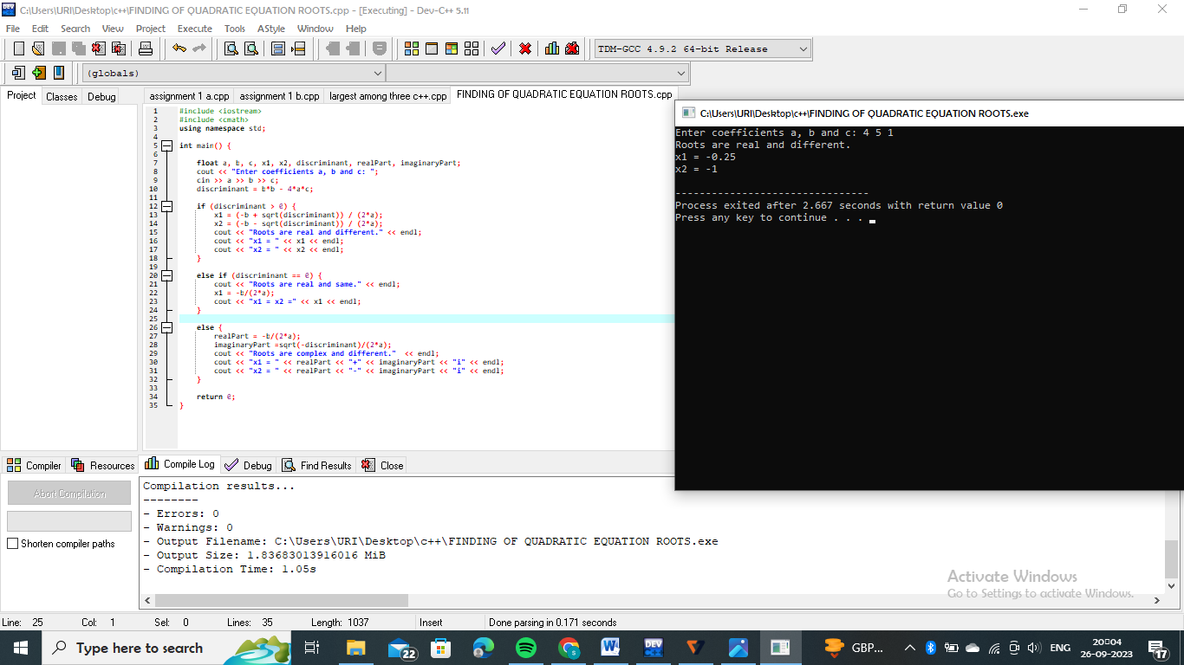

B) C++ Program to Calculate Sum of Natural Numbers

PROGRAM:

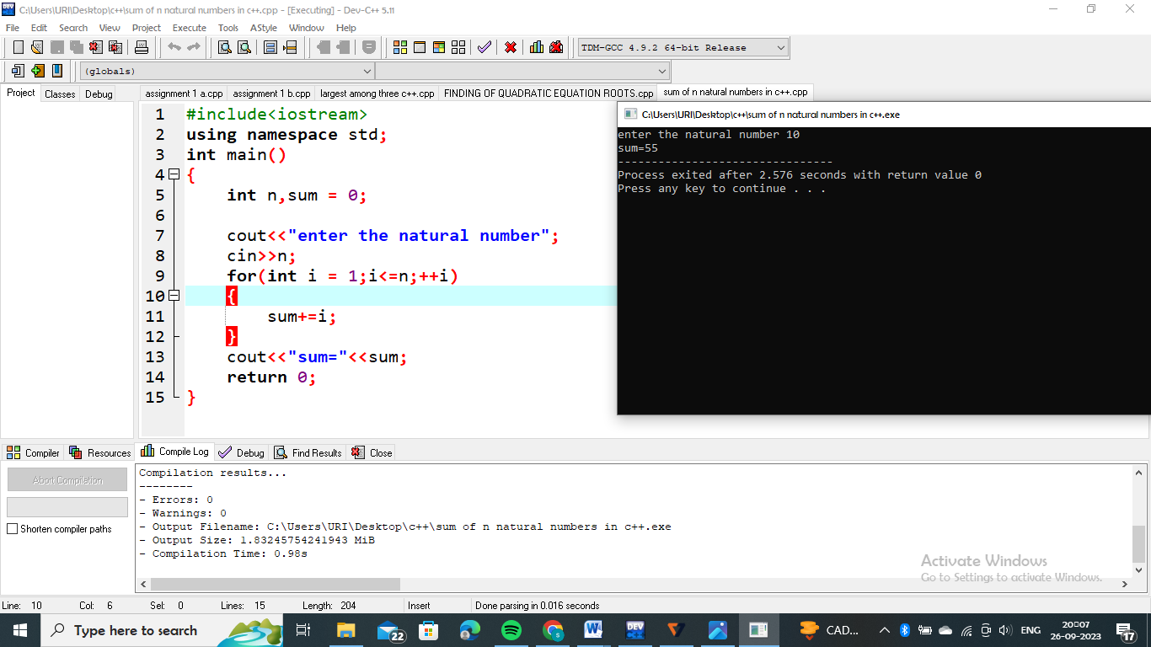

C) C++ Program to Check Leap Year

PROGRAM:

